SAURAV

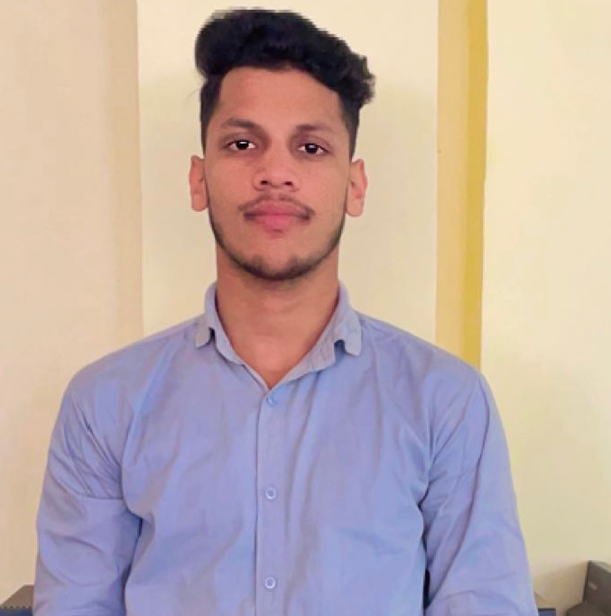

RZ 42/4 NAJAFGARH New Delhi (110013)

Mobile No.-9821365463

Email Id-Saurav982136@gmail.com

**CAREER OBJECTIVES**

Seeking a challenging position in a reputed Organization where I can learn new skills, expand my knowledge and leverage my learning.

**QUALIFICATIONS**

**Academic Qualifications**

|  |  |  |  |  |
| --- | --- | --- | --- | --- |
| **S NO** | Levels | Degree | Passing Year | University/Institute |
| 1. | **Graduation** | **Bachelor of Arts** | **2022** | **Delhi University** |
| 2. | **Intermediate** | **ARTS** | **2019** | **CBSE Board** |
| 3. | **High School** | **--** | **2017** | **CBSE Board** |

**Technical Qualifications**

|  |  |  |  |
| --- | --- | --- | --- |
| S No. | Diploma | Passing Year | University/Institute |
| 1. | **Advance Diploma in IT, Networking and Clouding** | **Appearing** | **Ministry of Skill Development and Entrepreneurship** |
| 2. | **Computer Operator & Programming Assistant** | **2022** | **NCVT** |

**WORK EXPERIENCE**

Fresher

**SKILLS**

• Interpersonal skills

* Communication skills
* Adapting environment
* Leadership quality
* Time management skills

**PERSONAL DETAILS**

Father’s Name Mr. BHARAT SINGH

Mother’s Name Mrs. MAMTA

Date of Birth 19-Nov-2001

Languages Hindi & English

**HOBBY AND INTEREST**

Exploring & Learning

**DECLARATION**

All of the above mentioned information is true to best of my knowledge.

Date:

Place: Delhi

(Saurav)